 | SAKR MANNING AGENCY  FOR RECRUITING EGYPTIAN LABOR ABROAD | Issue Date | 15.05.2022
 |  | Revision Date | 01.02.2024
 | Crewing Management Manual  Seafarer Employment Application | Revision | 1.3
 |  | Page | 4

Application For Position as | Electro-Technical Officer (ETO)
Register Code. | EO-4.062
Other Position (If Any) | Electrician
Register Date | 18.03.2026
Last up Date Data | Negotiable / Immediately
Expected Salary / Available Date
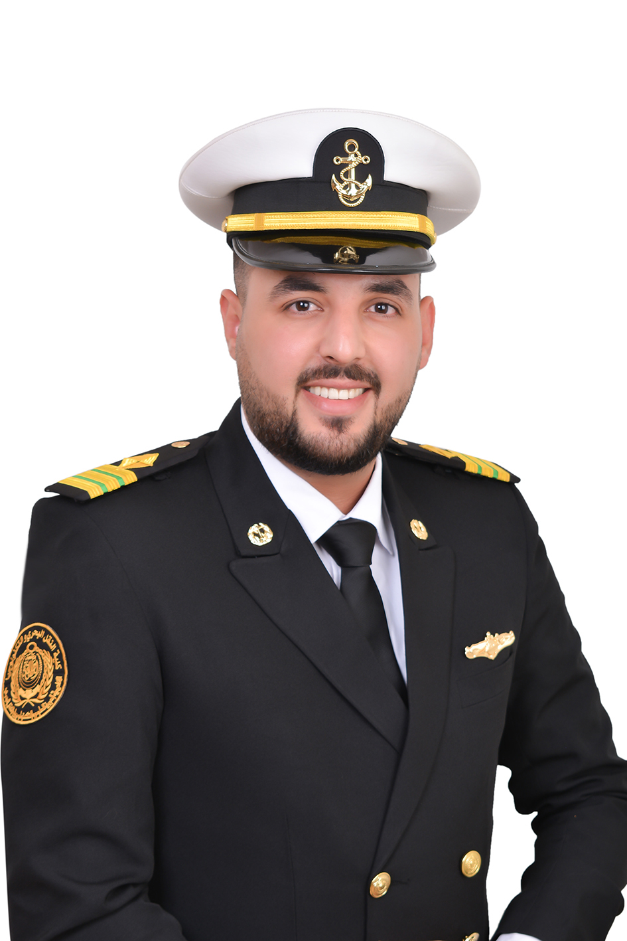

1. PERSONAL DETAILS
Full Name | MOHAMED MAHMOUD OSAMA MOHAMED HUSSEN SHISHKO
Date Of Birth | 18-09-1994 |  |  |  |  |  | Marital Status |  |  |  |  | Single ✔ |  |  |  |  |  | Married
Nationality | Egyptian |  |  |  |  |  | Height (Cm) |  |  |  |  | 183 |  |  |  |  | Weight (Kg) |  |  |  |  | 92
Place Of Birth | Egypt |  |  |  |  |  | Overall Size |  |  |  |  | XXL |  |  |  |  | Shirt Size |  |  |  |  | XXL
Nearest Port | Alexandria |  |  |  |  |  | Trouser Size |  |  |  |  | XXL OR 42 |  |  |  |  | Shoes Size |  |  |  |  | 44
2. EDUCATION
College / School | Arab Academy for Science, Technology and Maritime Transport (AAST
Marline Test | Issued Date |  |  |  | Result % |  |  | Issued By (Authority) |  |  |  |  |  |  |  | Issued At
English Language | Fluent |  |  |  |  | Good ✔ |  |  |  |  | Average |  |  |  |  | Poor
Arabic Language  ( ) | Fluent ✔ |  |  |  |  | Good |  |  |  |  | Average |  |  |  |  | Poor
3. CONTACT DETAILS
Home Address / City | Abu Qir, Alexandria, Egypt
E-Mail | eto.mahmoud.osama.shishko@gmail.com |  |  |  |  |  | Mobile / Tel |  |  |  |  |  | +201093326048

4. TRAVEL DOCUMENTS
Type | Document No. |  |  | ISS. Date |  |  | Exp. Date |  |  | ISS. By (Authority) |  |  |  |  |  |  |  | Place of Issue
Passport | A44512147 |  |  | 08/03/2026 |  |  | 07/03/2033 |  |  | Egyptian Authority |  |  |  |  |  |  |  | Alexandria
Seaman Book | S00062311 |  |  | 18/02/2026 |  |  | 26/01/2030 |  |  | EAMS |  |  |  |  |  |  |  | Alex.
Other Seaman Book

5. PROFESSIONAL QUALIFICATION / CERTIFICATE OF COMPETENCY
Certificate Name |  |  | Number | Issue Date |  |  |  |  | Expiry Date |  |  |  |  | Issued By |  |  |  |  |  |  | Issued At
COC ( Rank) ……… ETO ….. |  |  | 598 | 16-02-2026 |  |  |  |  | 26-01-2030 |  |  |  |  | EAMS |  |  |  |  |  |  | Alex.
GOC |  |  |  |  |  |  |  |  |  |  |  |  |  | NTRA |  |  |  |  |  |  | Cairo
6. NEXT OF KIN / EMERGENCY CONTACT
Full Name |  | Aya Osama |  |  |  |  | Relationship |  |  |  | Sister
Address / Country |  | Alexandria, Egypt
Tel. No./ Mobile |  | +201279796449 |  |  |  |  | Email |  |  |  | ayao47357@gmail.com
7. HEALTH CERTIFICATES & VACCINATIONS
Flag State |  | Number |  |  | Issue Date |  |  |  | Expiry Date |  |  |  |  |  | Issued By |  |  |  |  | Issued At
International Medical |  | 57615 |  |  | 01/03/2026 |  |  |  | 29/02/2028 |  |  |  |  |  | EAMS |  |  |  |  | EMA - Egypt
Yellow Fever |  | 8423 |  |  | 25/07/2018 |  |  |  | Life Long |  |  |  |  |  | Ministry of Health |  |  |  |  | EMA - Egypt
Cholera |  | N/A |  |  | N/A |  |  |  | N/A |  |  |  |  |  | Ministry of Health |  |  |  |  | Ministry of Health (KSA)
Covid-19 |  | Vaccination Name |  |  | First Dose |  |  |  | Second Dose |  |  |  |  |  | VCC01052200858 01/05/2022
 |  | Sinopharm FD5613 |  |  | 17/08/2021 FD5613 |  |  |  | 12/09/2021 FF7416

8. MARINE COURSES
Course Name | Number | Issue Date | Expiry Date | Issued By / At
Personal Survival Techniques | 3615/25/EG | 27/01/2025 | 26/01/2030 | AASTMT
Proficiency In Personal Survival Techniques | 3615/25/EG | 27/01/2025 | 26/01/2030 | AASTMT
Fire Prevention and Fire Fighting | 5379/25/EG | 06/02/2025 | 05/02/2030 | AASTMT
Advanced Fire Prevention and Fire Fighting | 5379/25/EG | 06/02/2025 | 05/02/2030 | AASTMT
Elementary First Aid | 3164/25/EG | 23/01/2025 | 22/01/2030 | AASTMT
Medical Care Studies
Personal Safety and Social Responsibilities | 2672/26/EG | 22/01/2026 | 21/01/2031 | AASTMT
Proficiency Of Security Awareness Training Seafarers | 6097/25/EG | 06/02/2025 | 05/02/2030 | AASTMT
Proficiency as a ship Security officer ( PSSO )
Proficiency In Survival Craft & Rescue Boats | 4420/25/EG | 30/01/2025 | 29/01/2030 | AASTMT
G.M.D.S.S
Communications
Advanced Communications
ECDIS Advanced Simulator (Management Level)
ECDIS Simulator (Operation Level)
Prevention and Combating of Marine Pollution | 46425/24/EG | 05/12/2024 | Unlimited | AASTMT
Radar & ARPA Simulator and Search &rescue
ARPA Simulator and Search
Marine Radar and automatic Radar Plotting
Bridge resource Management (B.R.M)
Engine resource Management (E.R.M) | 6138/25/EG | 09/02/2025 | 08/02/2030 | AASTMT
Navigational Watch keeping
Proficiency for Rating forming part of Navigational watch (II/4)
High voltage training – operation of ship (1000 Volt and More) | 39450/24/EG | 14/10/2024 | Unlimited | AASTMT
Passenger Safety Cargo Safety and Hull integrity
Crowd Management Training
Crisis Management and Human Behavior Training
Safety training for Personal Prov. Direct Passengers
HUET with EBS | OPITO7paotQQMP3 | 24/04/2025 | 23/04/2029 | OPITO / ETSDC
Basic H2S Training | OPITOK9xl93KqZo | 09/05/2025 | 08/05/2027 | OPITO / ETSDC
ADNOC Offshore HSE Induction | ETSDC-58528/2025 | 22/04/2025 | 21/04/2027 | OPITO / ETSDC
Safe Welding | 224182/2025 | 22/04/2025 | 21/04/2028 | OPITO / ETSDC
Lifeboat Coxswain | 224404/2025 | 28/04/2025 | 27/04/2028 | OPITO / ETSDC
Evacuation Training | N/A | 08-05-2025 | 07-05-2027 | Numero Uno Training
Proficiency for Abel Seafarer Deck ( II/5 )
Engineering Watch keeping
Proficiency for Rating forming part of a watch in engine room
Abel Seafarer Engine
Proficiency for Abel Seafarer Engine ( III/5 )
Electro Technical Rating
Proficiency for Electro Technical rating ( III/7 ) | 598 (CoC) | 16/02/2026 | 26/01/2030 | EAMS / Alex.
D.p. induction/ d.p. advanced | 7165/26/EG | 18/02/2026 | 17/02/2031 | AASTMT
D.p. operator (unlimited)
Others

 |  | 9 - COMPLETE SEA – SERVICE DETAILS
Name: |  | Mahmoud Osama Mohamed Hussein Shishko |  |  |  |  | Rank: | ETO |  | Register Code: |  |  | S00062311
Company Name |  |  | Rank | Vessel Name/IMO Number | Flag | Signed On |  | Signed Off |  | Period | Vessel Type |  | D.W.T./ G.R.T |  | Engine Type | BH/ KW |  | Reason for Sign off
AL HAIL MARINE |  |  | Electrician | CREST STATION 1 : N/A | Panama | 01/01/2025 |  | 15/07/2025 |  | 5 Months, 14 Days | Accommodation Barge |  | 11652 |  | 5 x Caterpillar 3412 Diesel Engines | 3100 KW (5 x 620 KW) |  | End of Contract
Hiroki Ship Management |  |  | Electrician | HIROKI / IMO: 9181120 | Belize | 08/04/2023 |  | 22/04/2024 |  | 1 Year, 14 Days | Bulk Carrier |  | 27011 |  | Mitsui MAN B&W 6S50MC Diesel & Heavy Fuel Engine | 7428 KW (Main) & 1800 KW (3 x 600 KW Gen) |  | End of Contract
COLUMBIA SHIP MANAGEMENT |  |  | Asst ETO | OML INTERVENTION I / IMO: 9787326 | Panama | 18/03/2022 |  | 30/01/2023 |  | 10 Months, 12 Days | Jack-Up Barge |  | 8100 |  | 8 x Caterpillar C32 Diesel Engines | 7520 KW (8 x 940 KW) |  | End of Contract
Over Seas Marine Logistics |  |  | Asst ETO | OML INTERVENTION II / IMO: 9787338 | Panama | 13/10/2021 |  | 18/03/2022 |  | 5 Months, 5 Days | Jack-Up Barge |  | 8100 |  | 8 x Caterpillar C32 Diesel Engines | 7520 KW (8 x 940 KW) |  | End of Contract
Over Seas Marine Logistics |  |  | Asst ETO | OML JACOB / IMO: 9765691 | Panama | 30/09/2021 |  | 11/10/2021 |  | 11 Days | Jack-Up Barge |  | 3753 |  | 4 x Caterpillar Diesel Generators (50/60 Hz) | 3200 KW (Approx. 4 x 800 KW) |  | End of Contract
Over Seas Marine Logistics |  |  | Asst ETO | HIMS 6 / IMO: 9821574 | Panama | 10/07/2021 |  | 29/09/2021 |  | 2 Months, 19 Days | Jack-Up Barge |  | 7272 |  | 4 x Caterpillar 3512 Diesel Engines | 4800 KW (4 x 1200 KW) |  | End of Contract
10. REFERENCES
No | Company / Management / Country |  |  |  |  |  | Position |  | Name |  |  | TEL |  | EMAIL
1. | Al Hail Marine Services |  |  |  |  |  | Port Engineer |  | ALAA SALEM |  |  | 971544884944 |  | alaa.@alhail.me
2.
3.
11. DECLARATION
Please answer the following questions:
- Did you suffer, or presently suffer from, any disease likely to render you unfit for services at sea or likely to endanger the health of other persons on board?  If yes, please provide details _______________________________________________  ______________________________________________________________________ | YES ✔NO
- Did you suffer any accident, which rendered you temporary and/or partially disabled? | YES ✔NO
- Did you ever undergo psychiatric treatment | YES ✔NO
- Are you addicted to alcohol or drugs of any kind? | YES ✔NO
I hereby declare that the above facts and information are true and accurate. I further consent to the holding and processing by (i) the owners of any vessel on which I may be assigned from time to time and (ii) the Managers and any direct or indirect parent or subsidiary or associated or affiliated company of the Managers (together referred to as "the Companies") for the purposes of my employment, of personal data about me contained herein, or provided to any of the Companies at a later date, including with respect to personal and pensions administration, employee management and as required to comply with any laws, regulations or contracts applicable to any of the Companies or their businesses. I understand that this data will be stored in the Managers’ database for the purposes of my current or future employment arranged by the Managers. Further, I confirm that the above may involve the transfer of my personal data within the Managers’ organization.
Place_ Alexandria, Egypt__________ Date _______15/03/2026____________________ Signature _____________MAHMOUD OSAMA_________________
12.For Office Use Only
Initial assessment of applicant for further recruitment
Comments

Responsible person

Name / Signature _______________________________________________ Date ________________________________

